**My First Webinar: Start Kafka Clusters in SECONDS**

You're about to learn how to start Apache Kafka in the next section, but I recommend you also attend my webinar ⬇️

**This is my FIRST webinar in 5 years of teaching and I'm super excited for it!**

[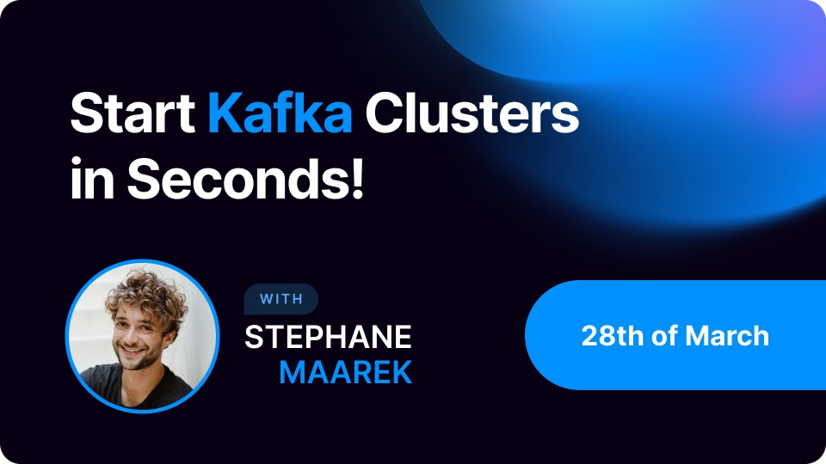](https://app.livestorm.co/conduktor/webinar-the-fastest-way-to-start-kafka-ever?utm_source=Udemy&utm_medium=Udemy-email&utm_id=Udemy)

I want to tell you about something that I think you are going to love.

**With [Conduktor](https://www.conduktor.io/start-kafka-faster-than-ever" \t "_blank), you can now start Kafka clusters in a couple of clicks (including Schema Registry!)**. We built this powerful new feature to get you up and running with Apache Kafka faster than ever before.

**Join** **me** for an action-packed webinar on [**March 28th, 2022**](https://app.livestorm.co/conduktor/webinar-the-fastest-way-to-start-kafka-ever?utm_source=Udemy&utm_medium=Udemy-email&utm_id=Udemy). In just 15 minutes, I will deep dive into this new feature, answer your questions and tell you about some of the other cool stuff we're building at Conduktor.

](https://app.livestorm.co/conduktor/webinar-the-fastest-way-to-start-kafka-ever?utm_source=Udemy&utm_medium=Udemy-email&utm_id=Udemy)

This is not to be missed and places are limited so book now!

](https://app.livestorm.co/conduktor/webinar-the-fastest-way-to-start-kafka-ever?utm_source=Udemy&utm_medium=Udemy-email&utm_id=Udemy)

I hope you can join us to explore this game-changing new feature that we've developed for the Apache Kafka community.

This capability is open to all users, absolutely free in our latest version of **Conduktor.** You can learn all about it and [even try it out yourself right here.](https://www.conduktor.io/start-kafka-faster-than-ever)

**Happy learning!**

Stephane